# Project 1 - Deploying a Multi-Tier Website Using AWS EC2

Solution Steps: -

1. EC2 instance has been launched in default VPC.

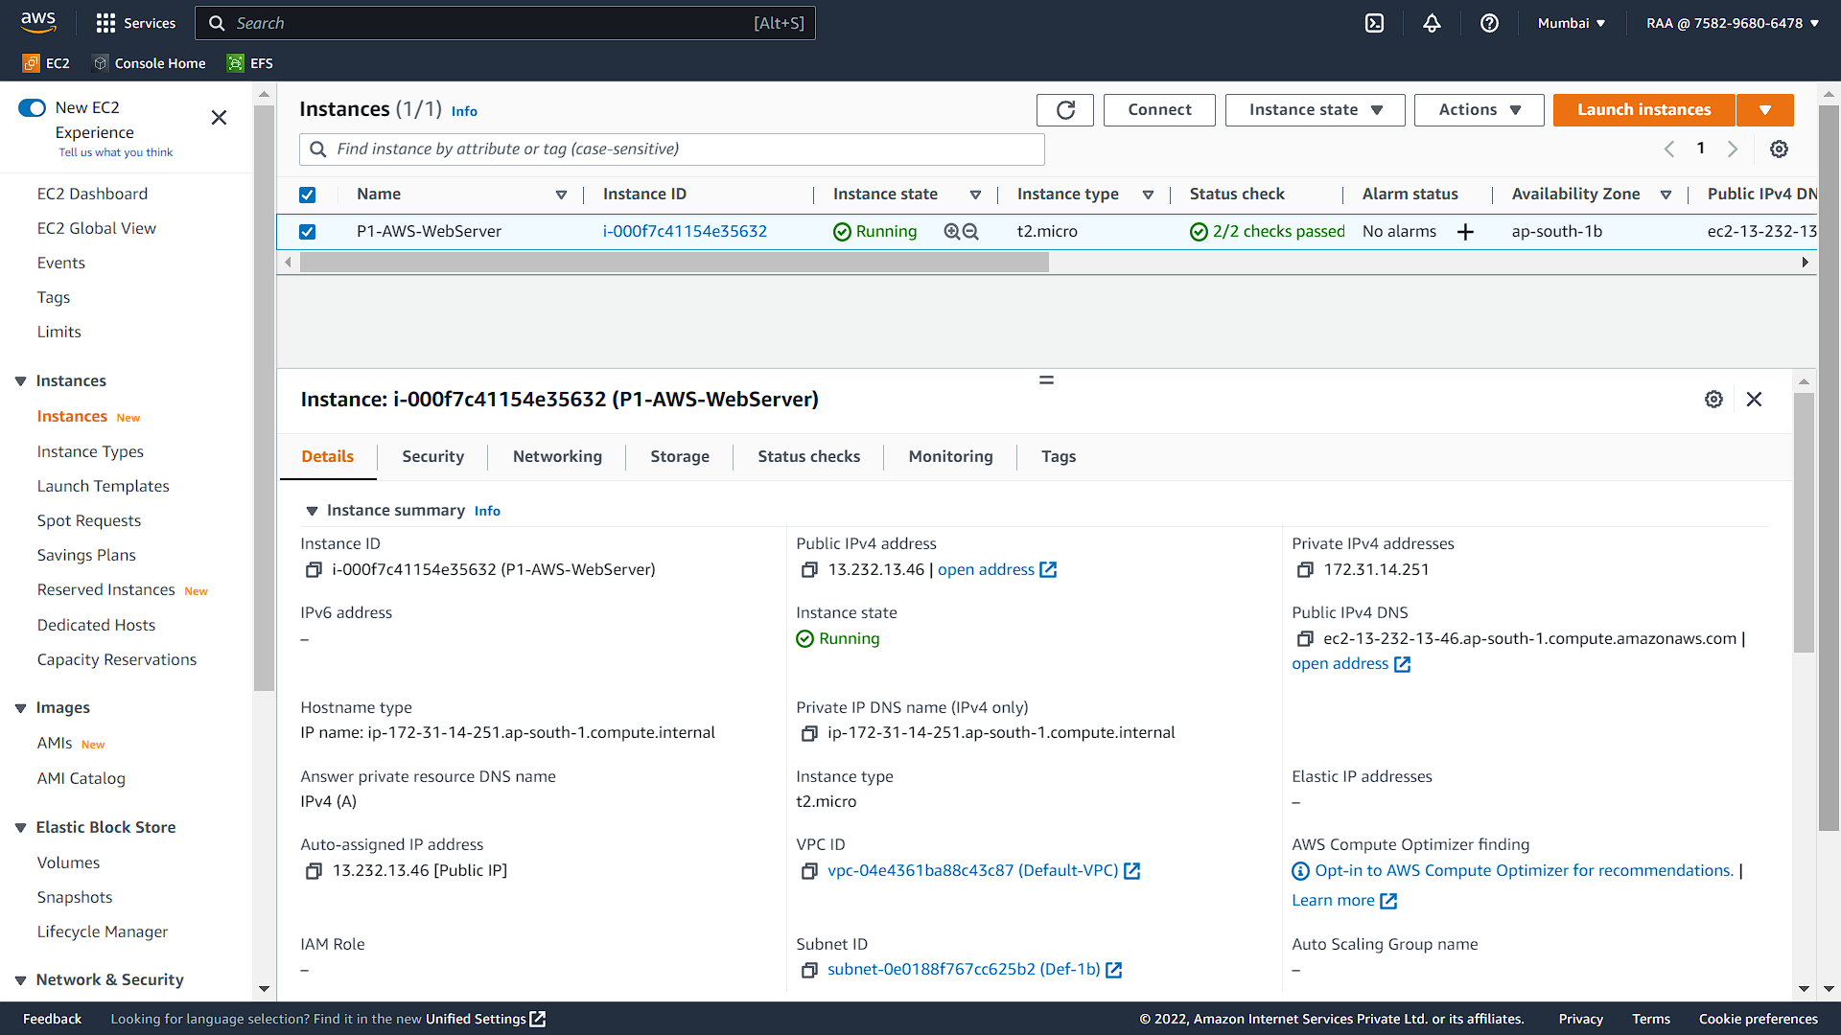

3. Created an RDS instance with MySQL Database Engine.

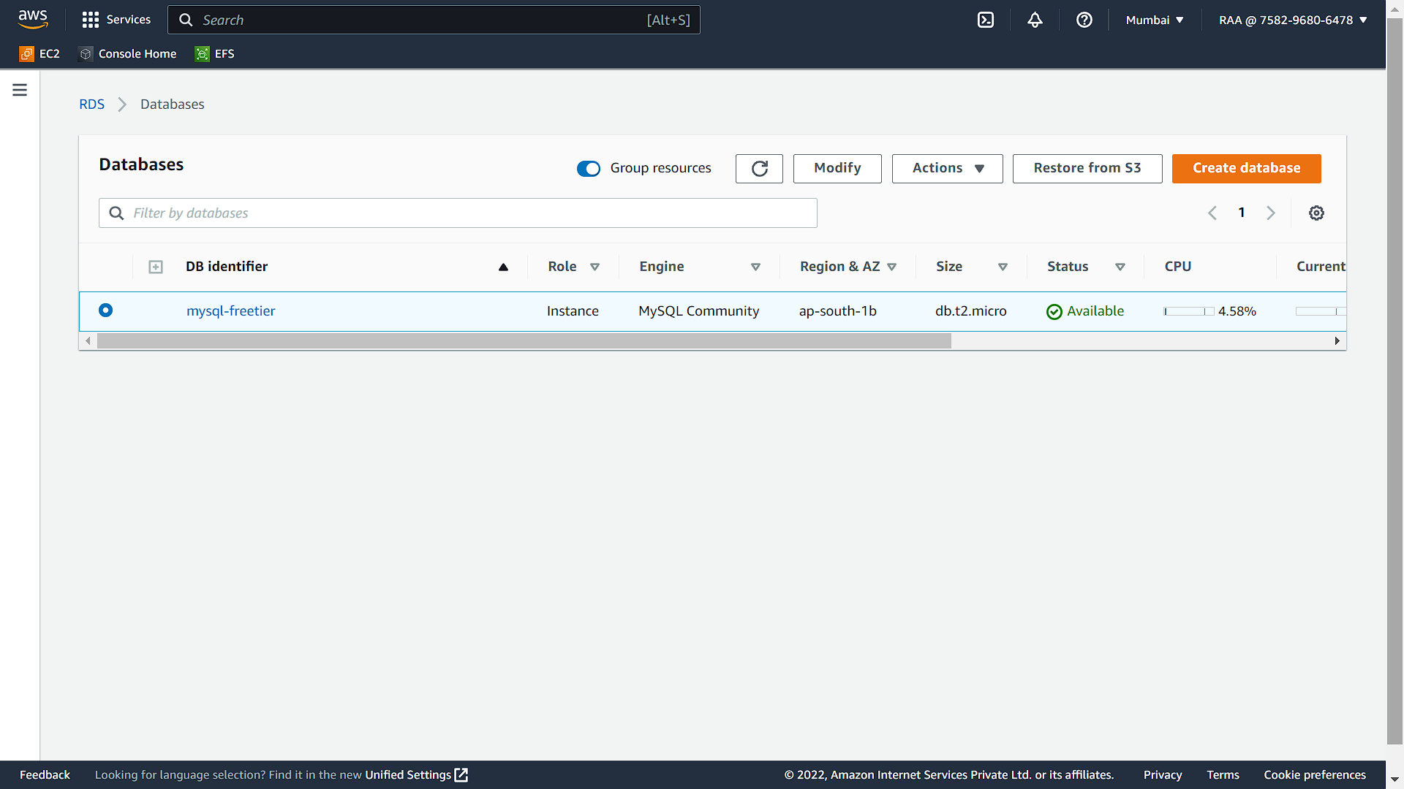

4. Logged into the EC2 instance to set the webserver environment, installation of php, mysql.

For Webserver:

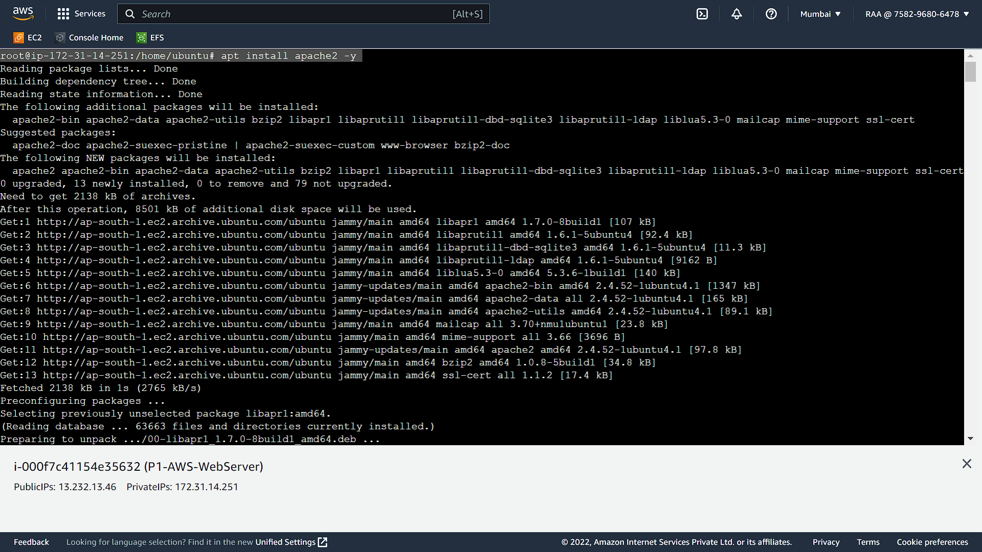

For PHP and MySql setup:

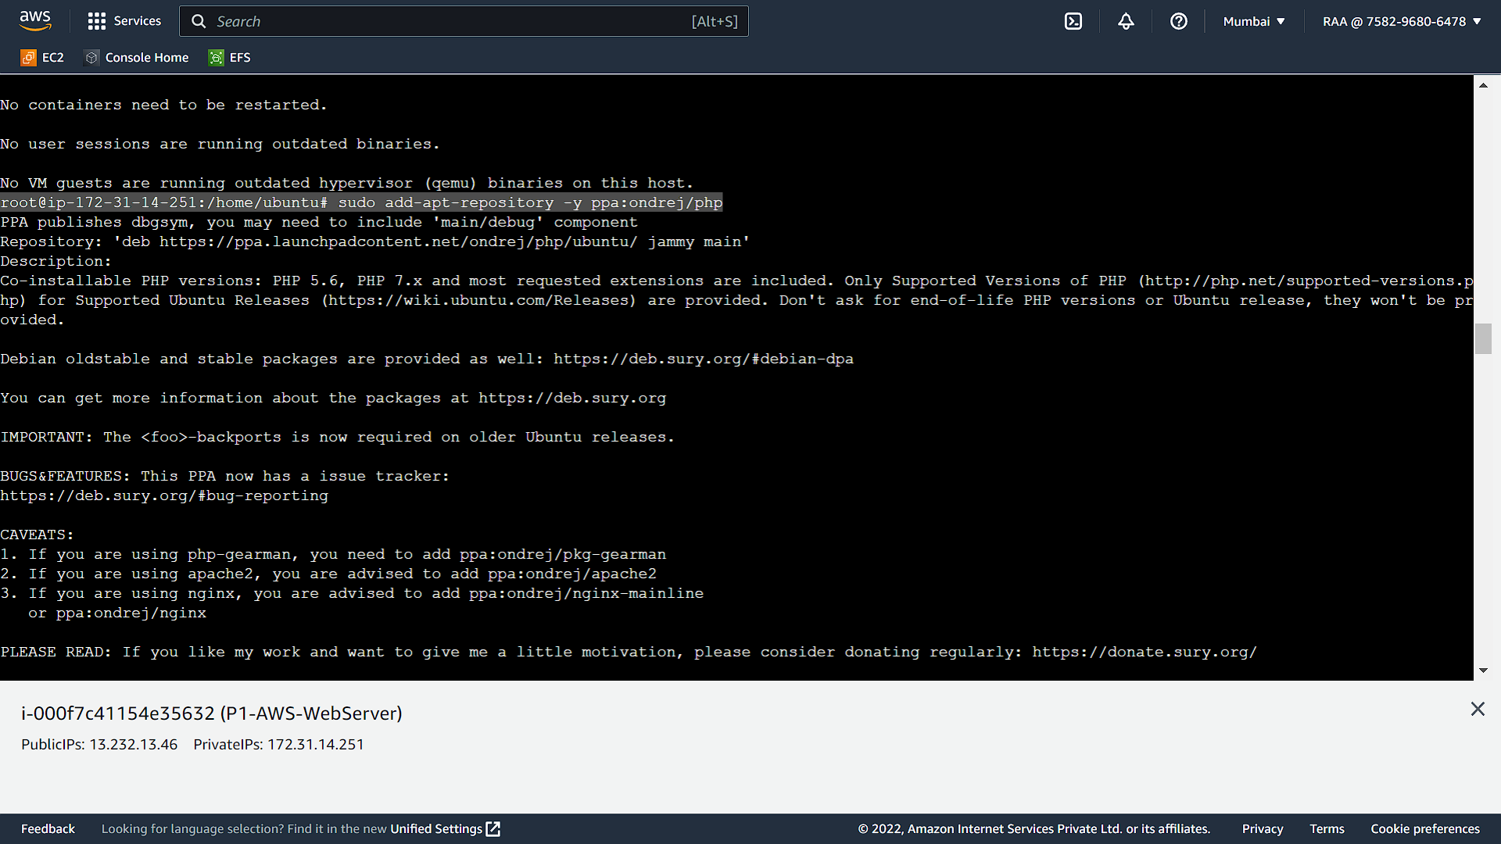

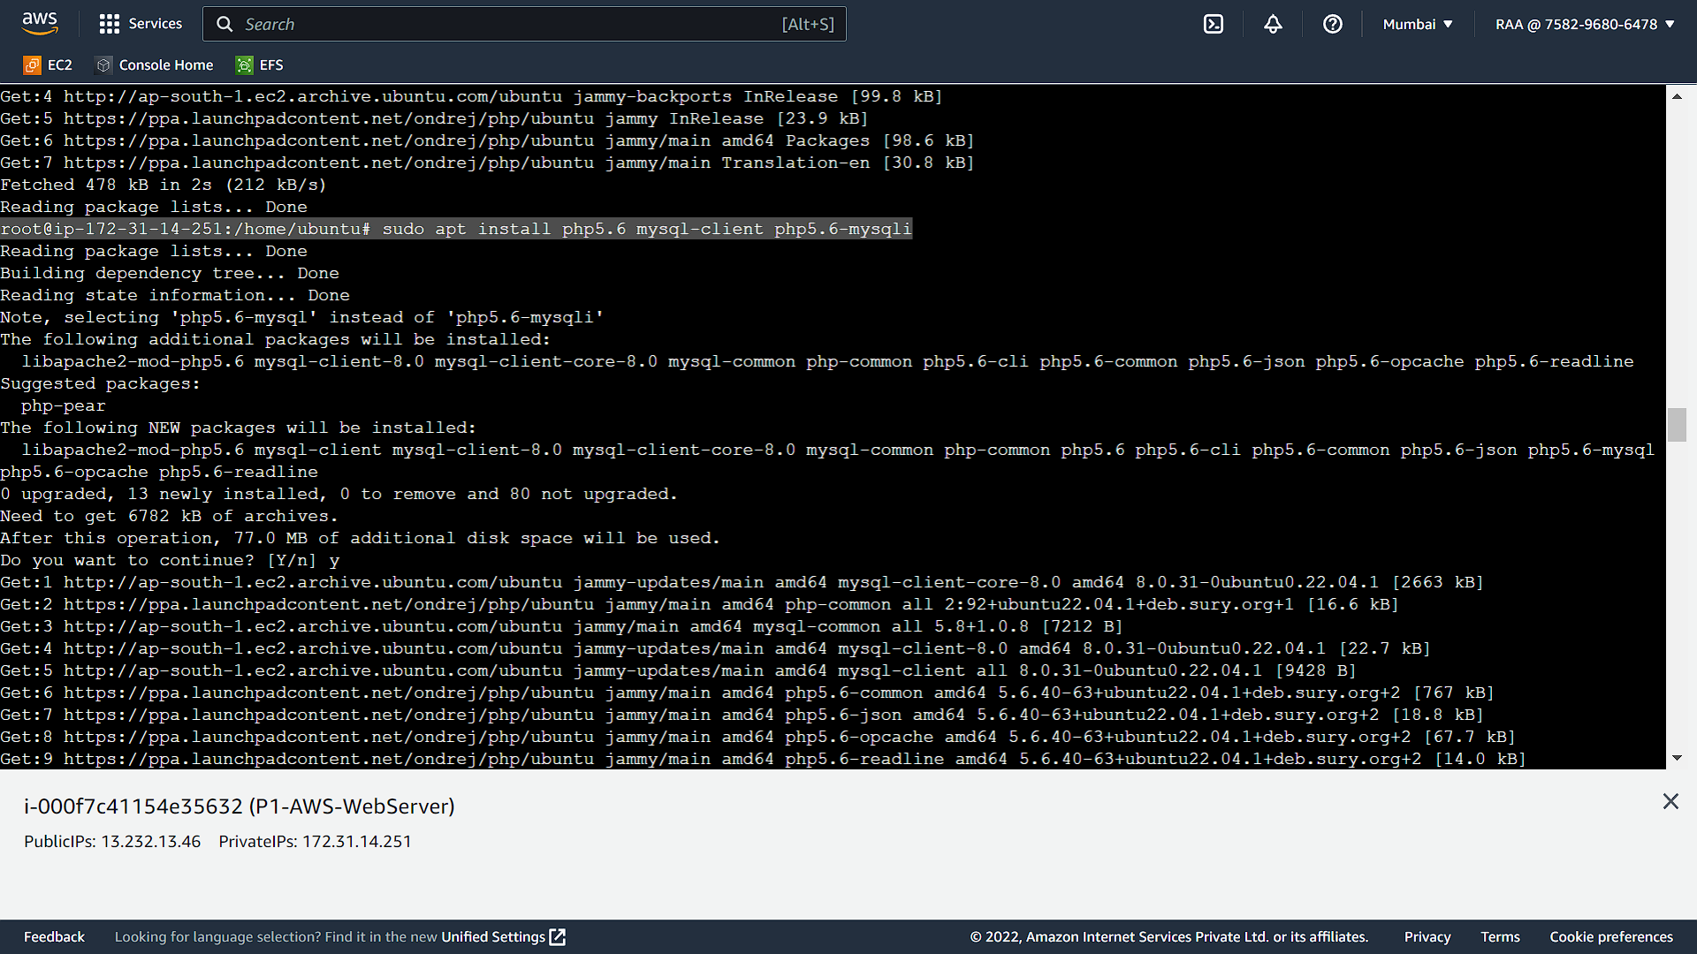

Using MobaXterm, requested code files have been copied to the ec2 instance under below directory.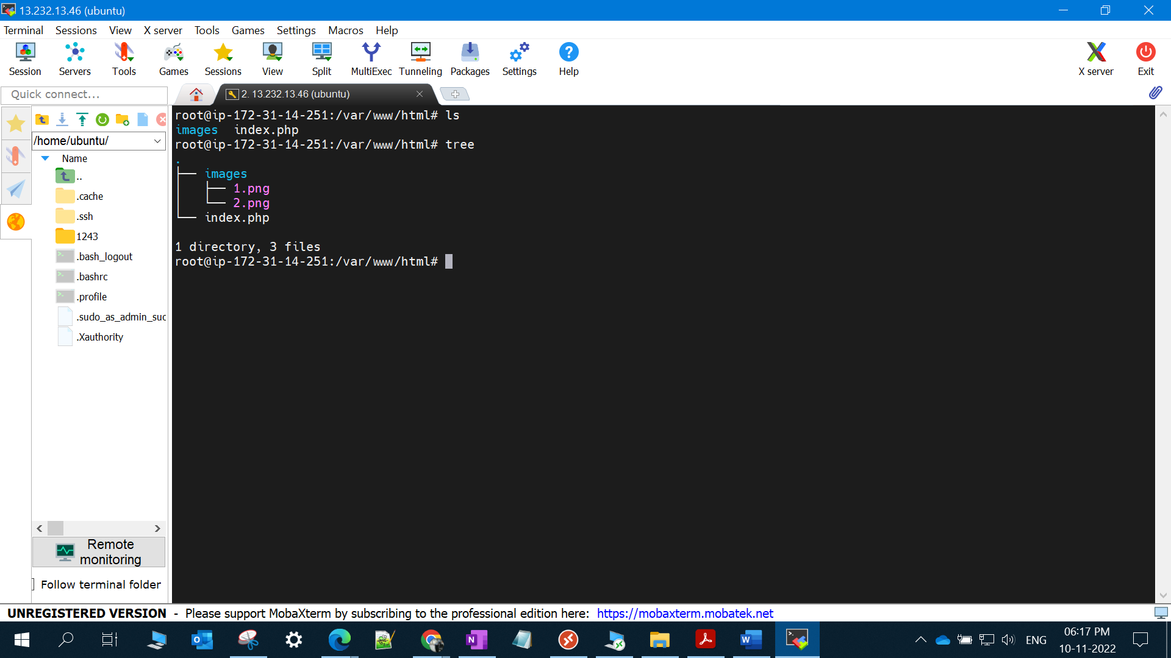

Connected to Mysql database to create the table.

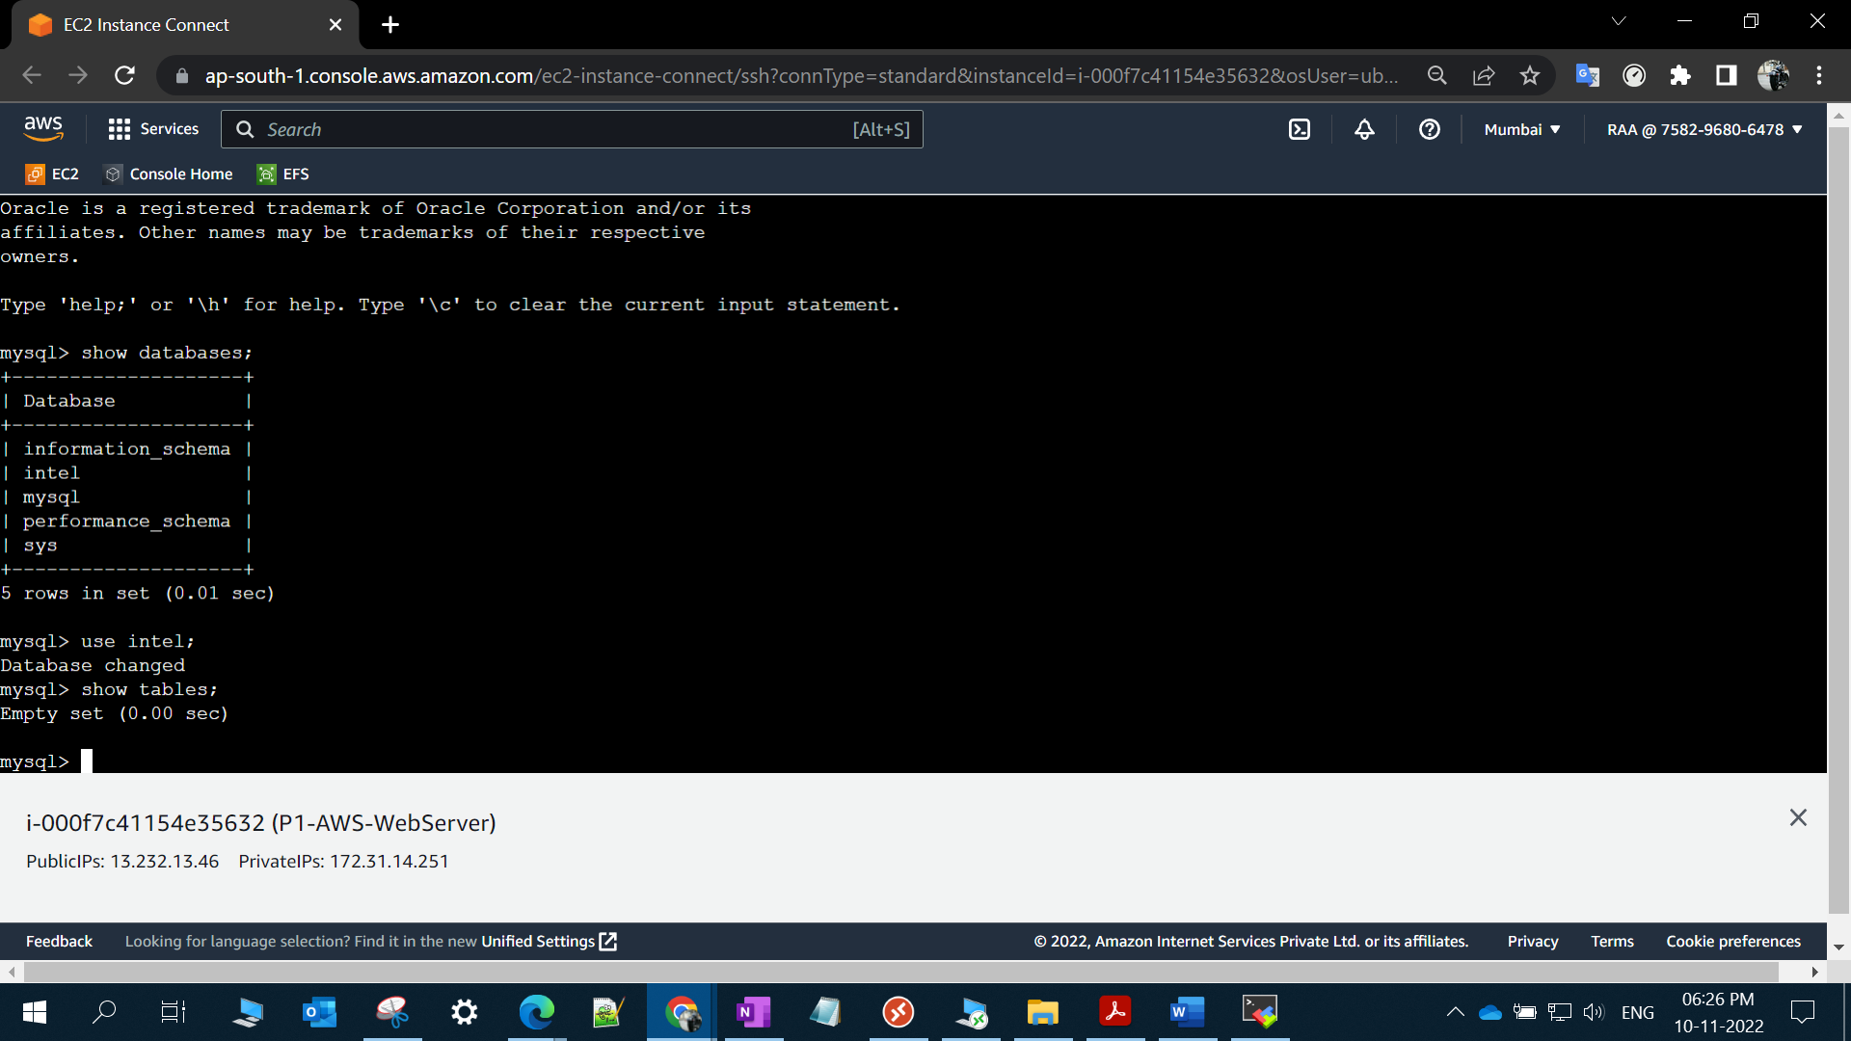

Table has been created.

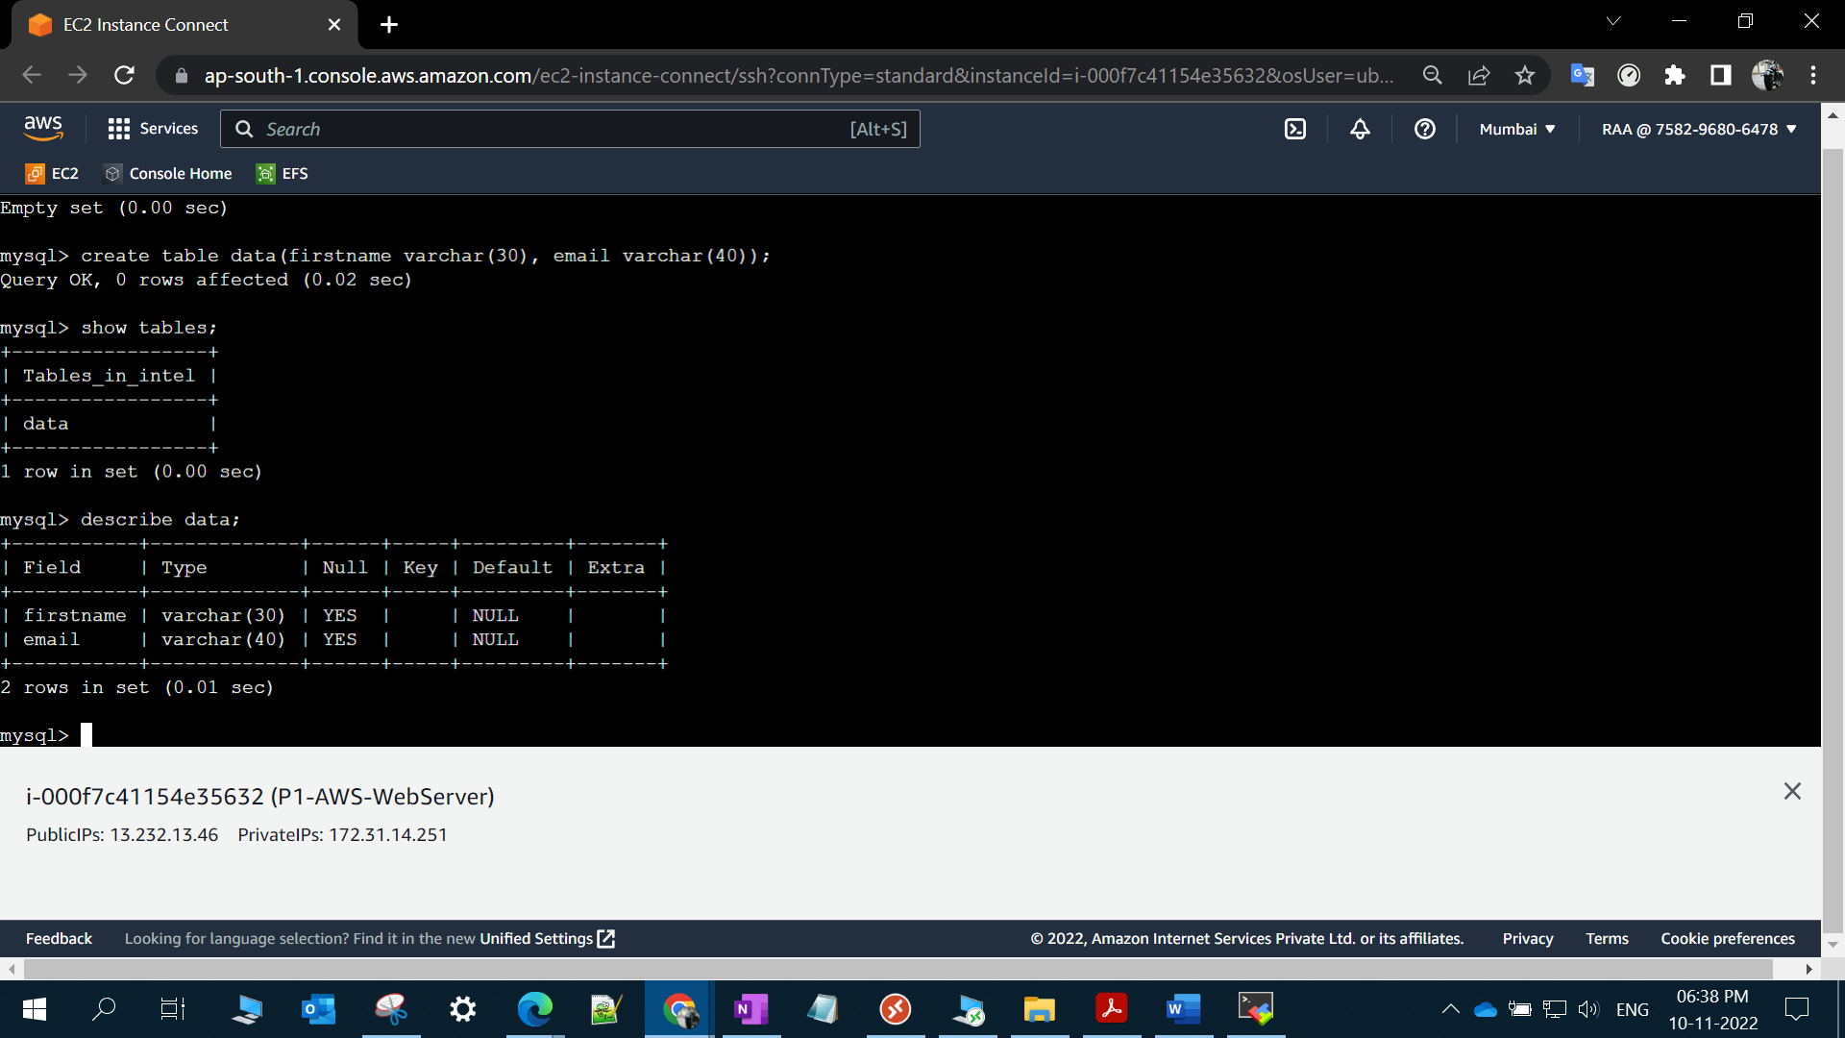

Checking the Website…

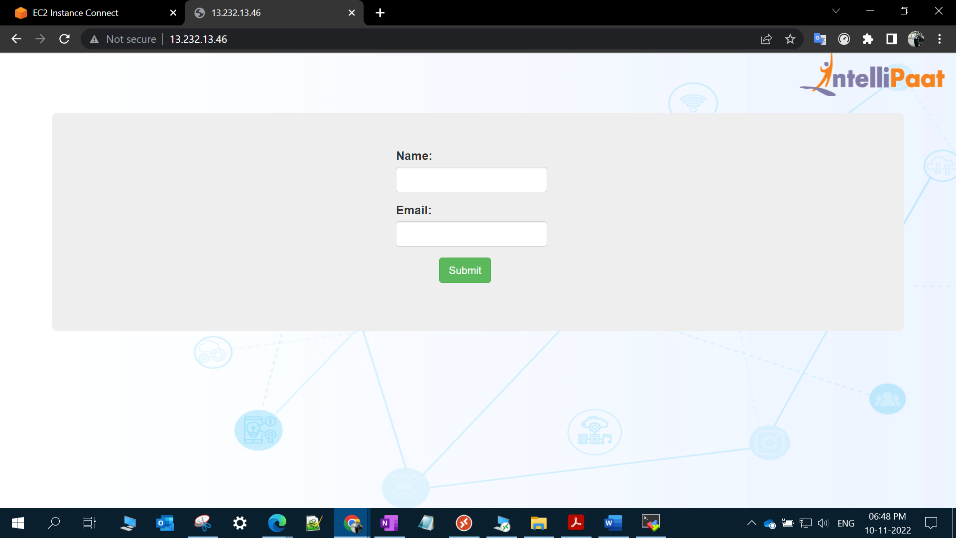

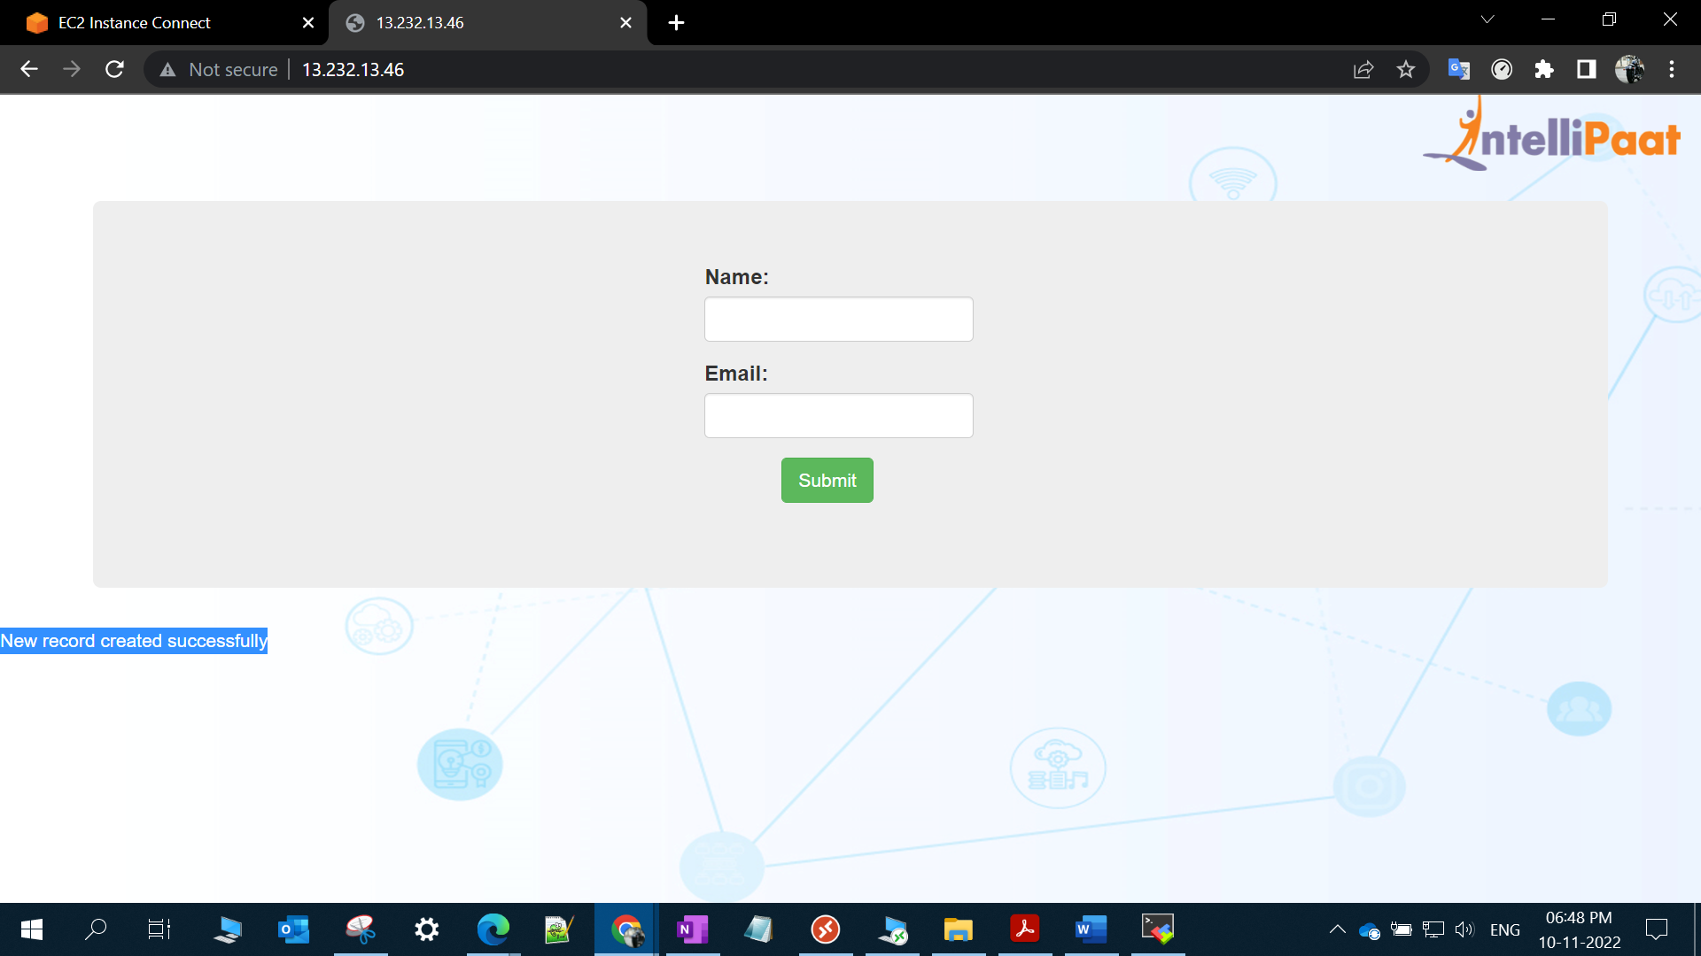

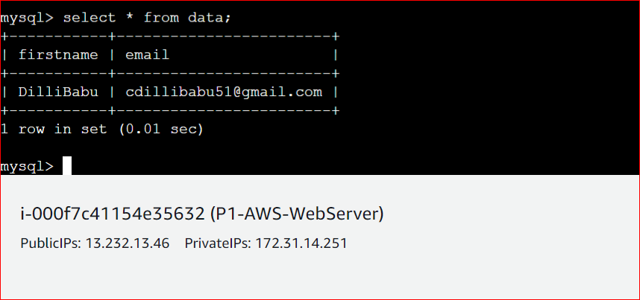

Website working fine.

To make the website HA, creating the Autoscaling.

A) AMI Creation from main instance.

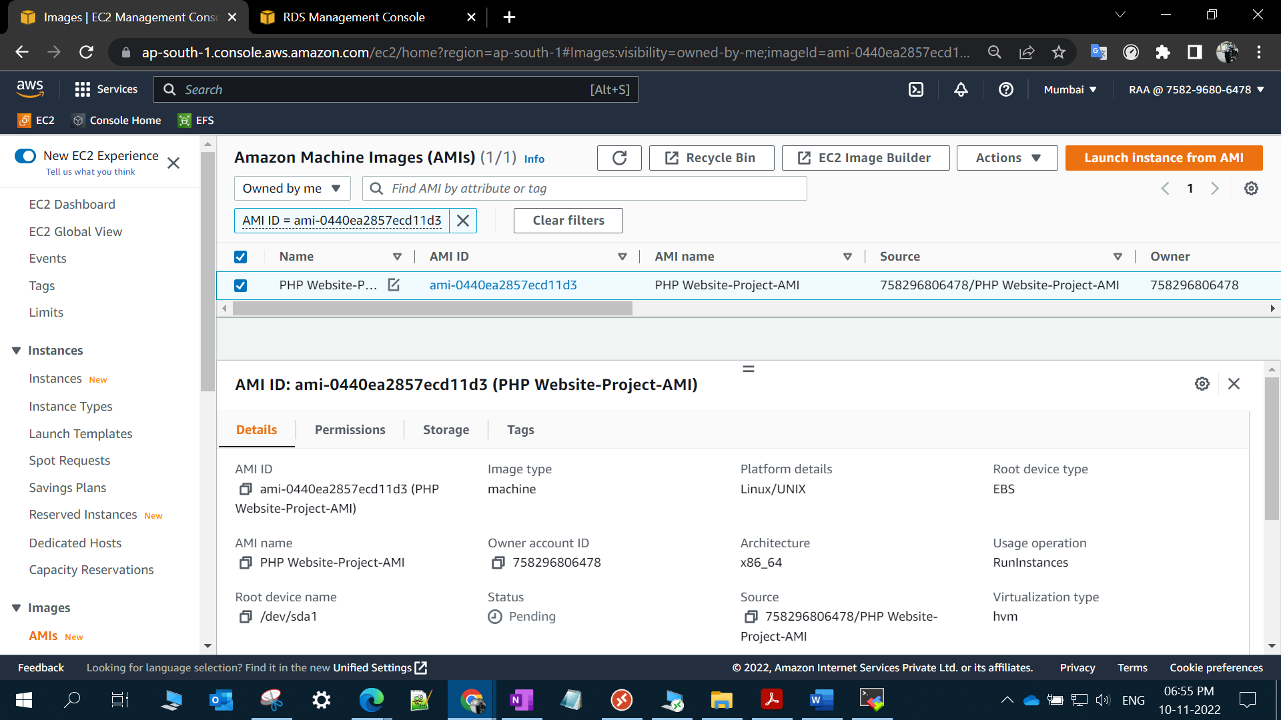

B) Launch Configuration created.

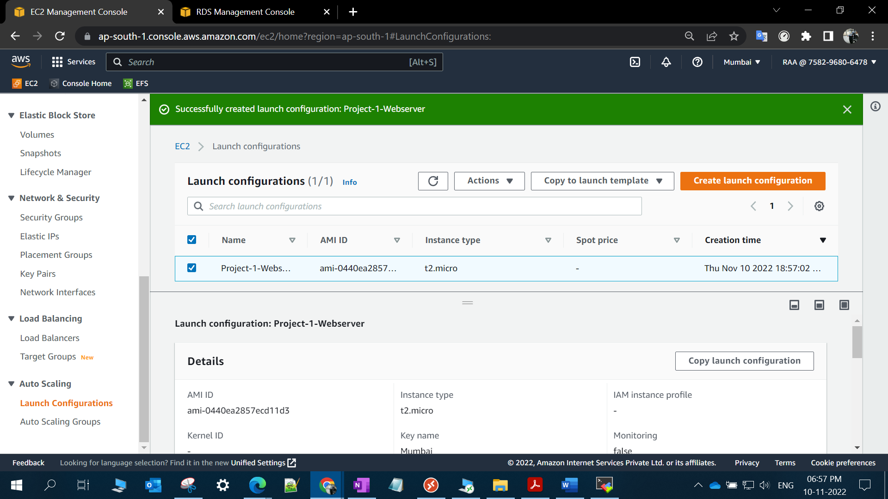

C) Autoscaling group is created.

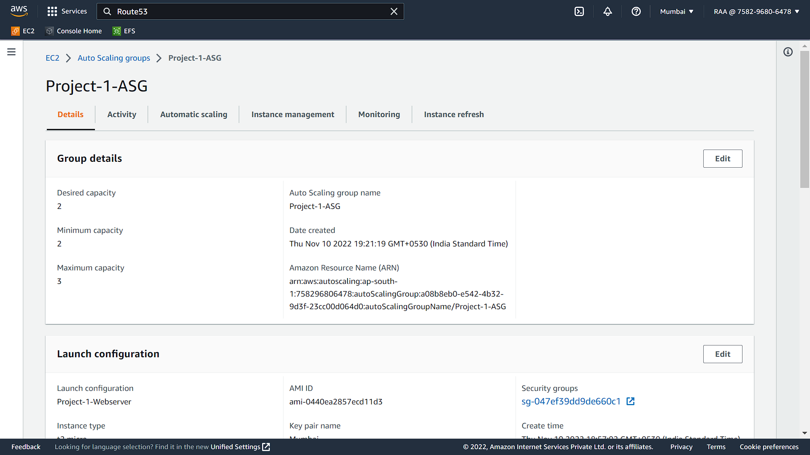

Dynamic Scaling also created for scale up/down.

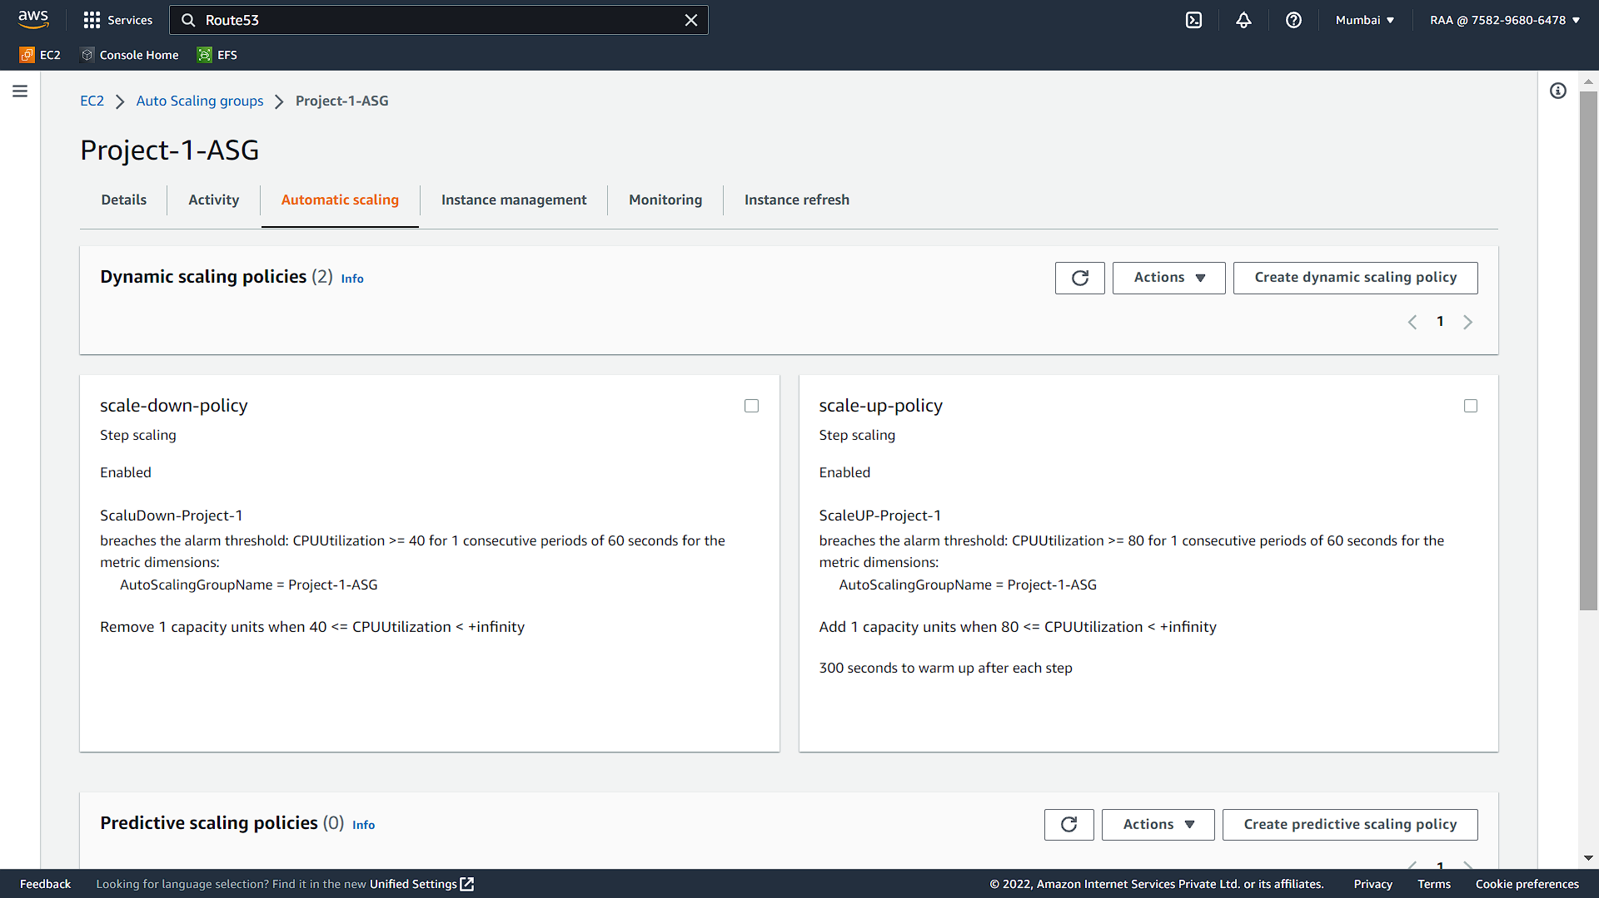

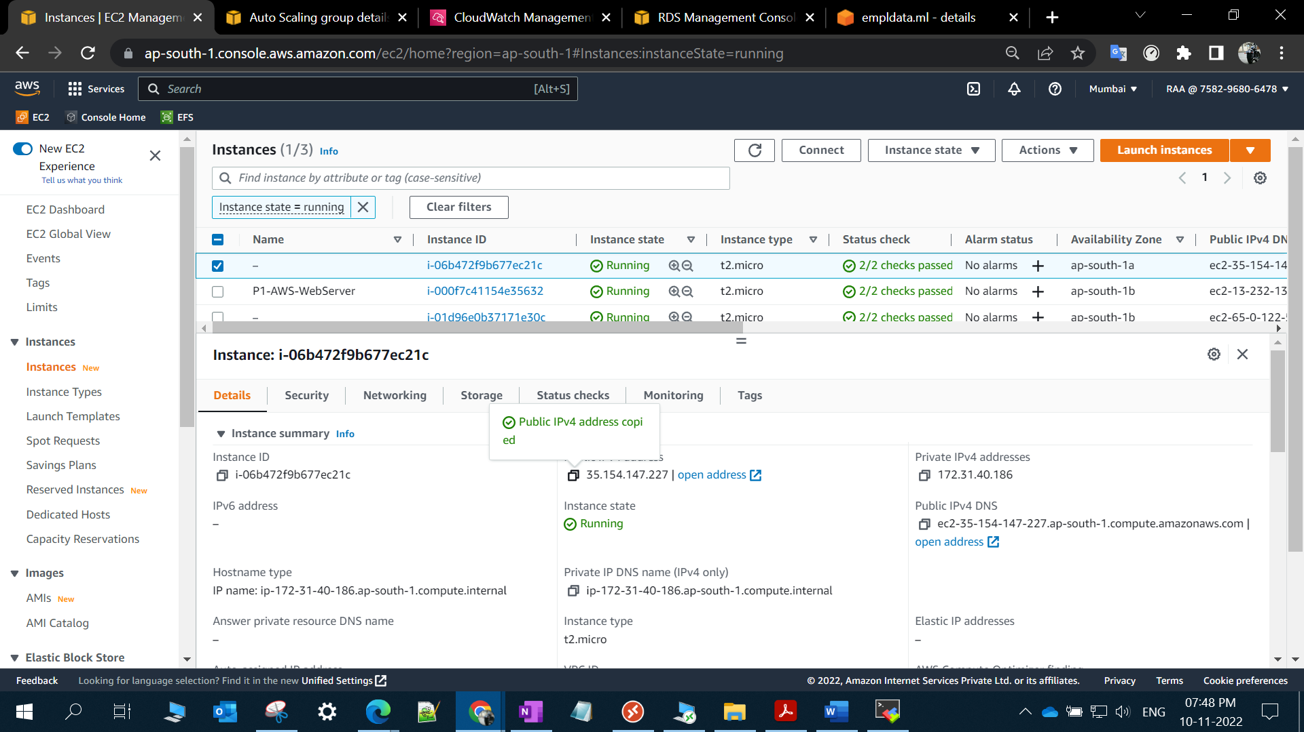

Website is running after setting autoscaling.

